**GIT and GIT HUB**

[**ananthgithub@gmail.com**](mailto:ananthgithub@gmail.com)

**usual password**

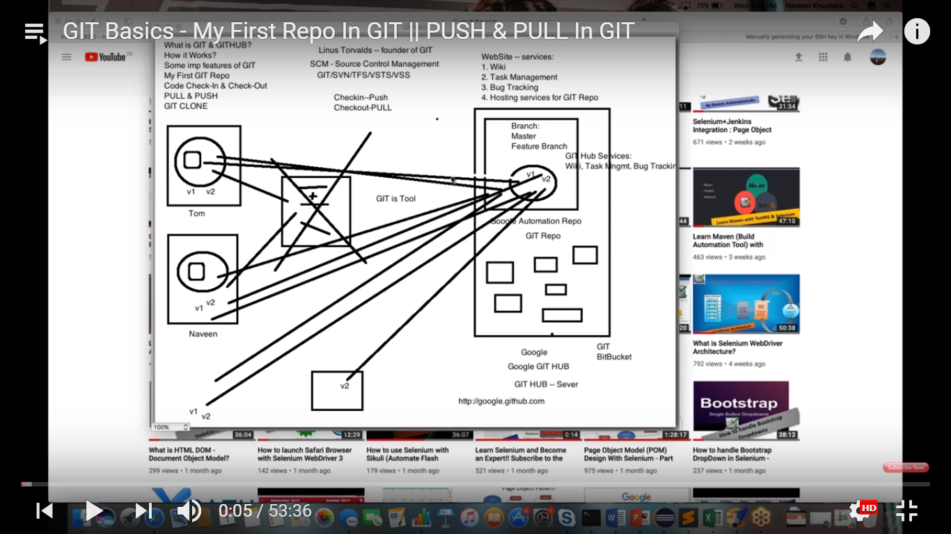

I have machine and in it I have eclipse . I have created a project.

Tom is there and he is also created a project. We need to merge the code.

I need to a take a pendrive copy his code and the merge it.

Therefore we have a git repository . We create a git repository .So we have hosting service over the internet called as git hub. A guy is working in google , so he will create google account with git hub repository.

Tom will have his own email id and I will have my own email id .We will contact to google and they will contact to git hub and create a space on git hub .

I can login to this git hub and access to this particular service.

Git hub is a website which provides different services – You can create

* Wiki pages
* Tasks management tool
* Bug tracking
* Hosting services got GIT repo

Dev ops will guy will create an admin account into this repository [admin@google.com](mailto:admin@google.com)

And they will create one repository for us.

For a team they will create repository - Google automation repository

I will push the code into this repository. All team members will push the code to this repository.

This repo will have branches

* > Master branch
* -> Feature branch

We can push the code to master branch or feature branch. We should have access to create the branches and push the code into this repo into respective branch.

Everyone is pushing the code. Latest version of the code(v1) will be created over here in git hub repo.

Tomorrow I come to office and get the latest version of the code (pull the code v1 )

Check in – push and

check out – pull

All are on the same page .

Now I again push the code – v2

Ultimate target is all will be on this same page. He will be notified and he will pull the latest code.

New guy will be given access to the particular repository .

All guys will have latest code .This is called centralized repository and this is called git repository .

Git repository is hosted in git hub. All companies have registered and created their own repository like hts://google.github.com

Git hub – hosting service .

GIT – tool – check in and check out , versioning is happening through git

Linus Torvalds – created git concept.

You can raise a defect against their repository . I have pushed the code into git

Repo – tomorrow , if I find issue in google chrome , In this particular git repository , against that repo they provide services –

* Wiki pages
* Tasks management tool
* Bug tracking
* Hosting services got GIT repo

GIT is SCM – source control management .- version control ,it is a tool

SVN, TFS,VSTS,VSS , BIT Bucket

GIT is a very good tool

Create an account in github.com

[ananthgithub@gmail.com](mailto:ananthgithub@gmail.com)

Username : anariky1

Usual password

Click on + symbol and click new repository

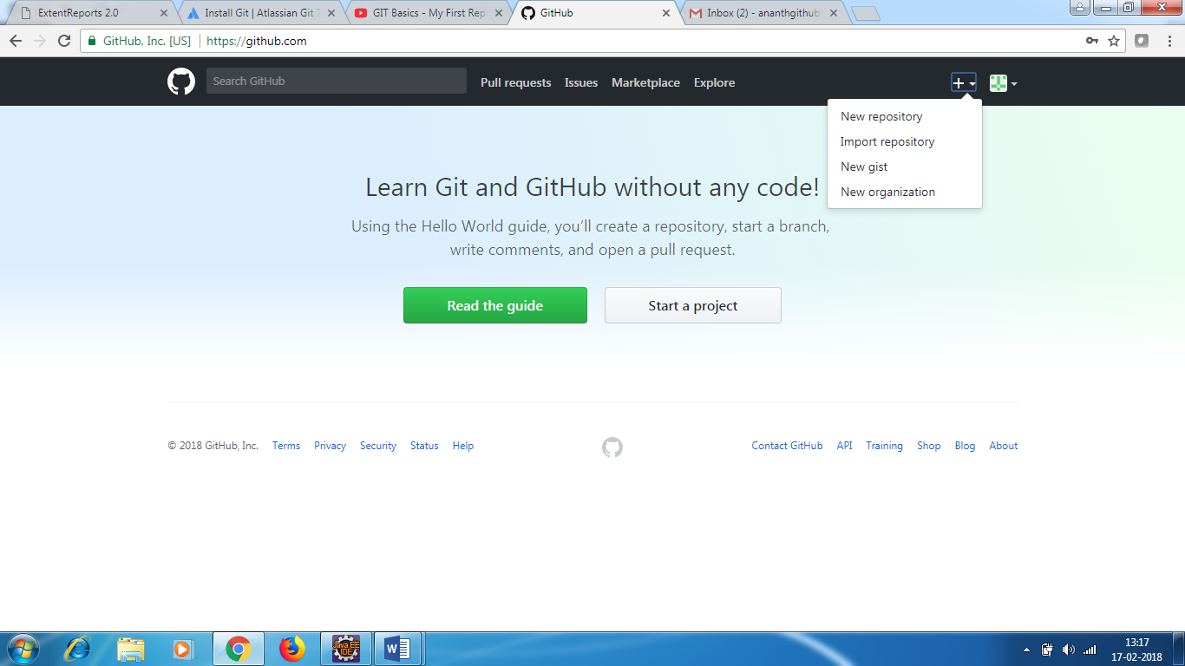

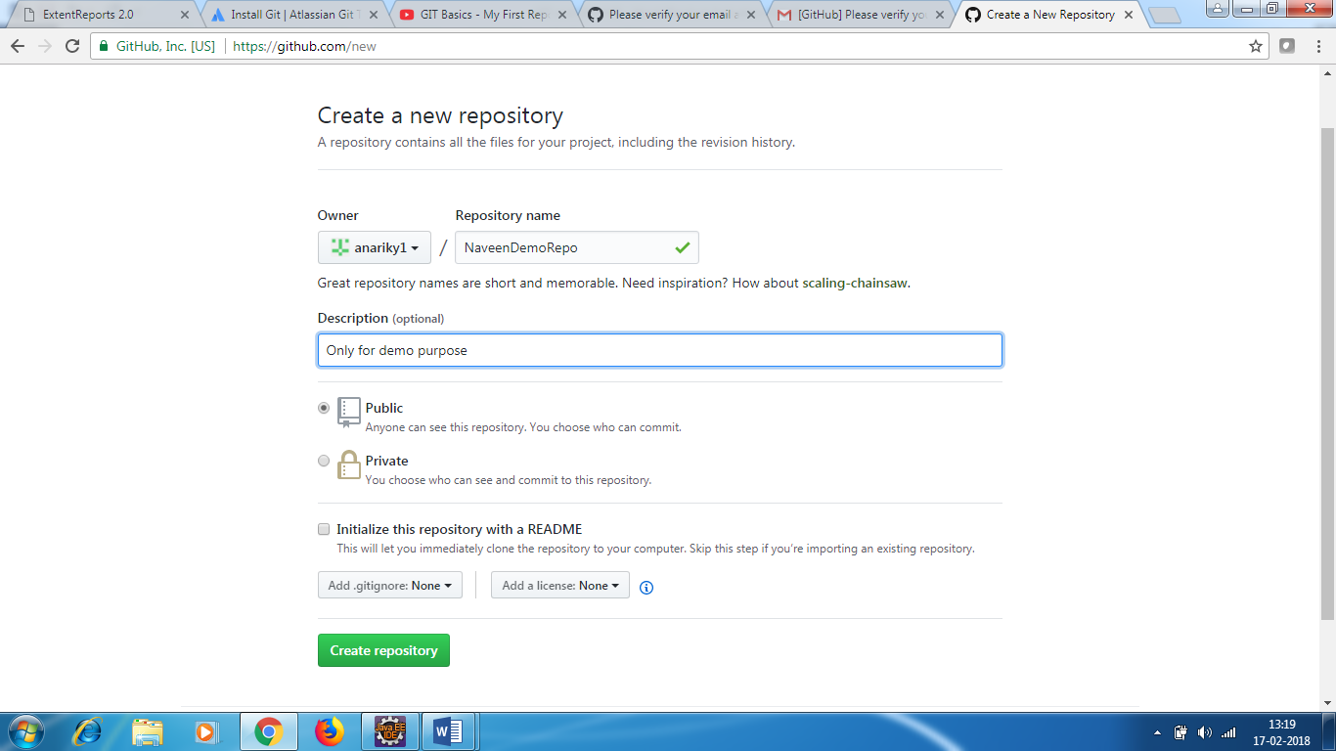

In company -you decide who can see the code.

Click create repository

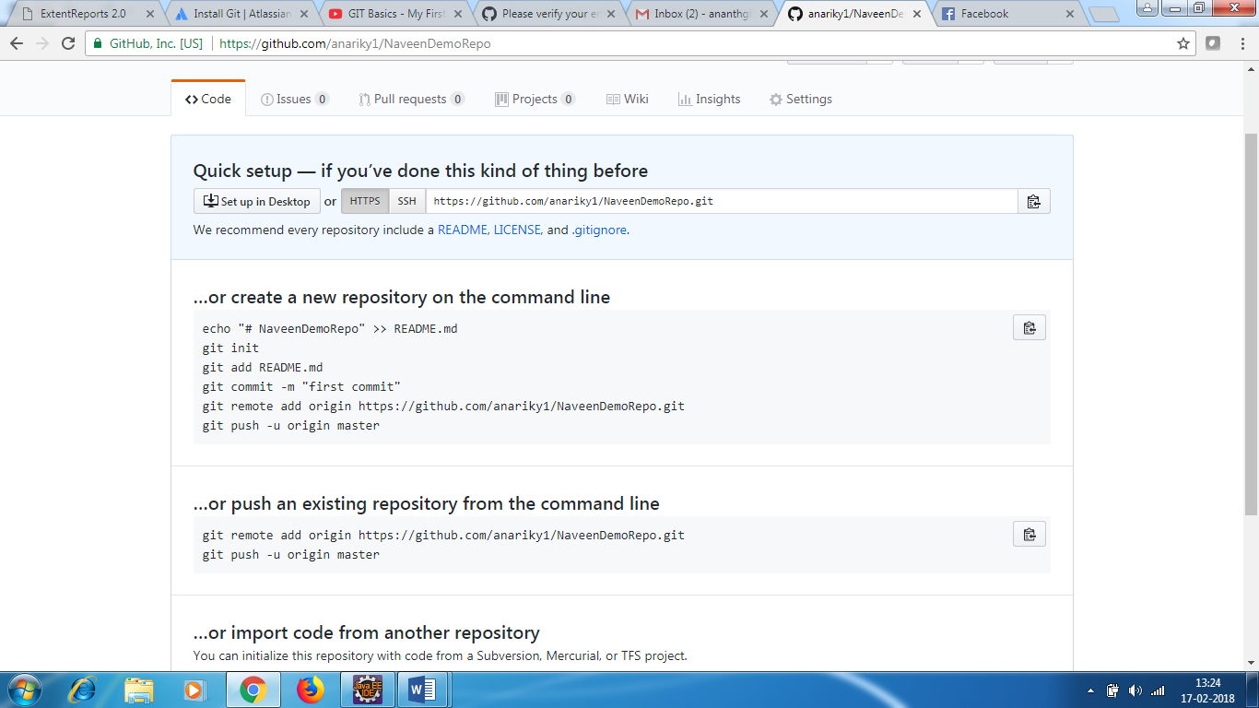

* Create a Maven project in eclipse (NaveenDemoGitRepo)
* Capture the path of the project
* Go to command prompt
* Go to the project path